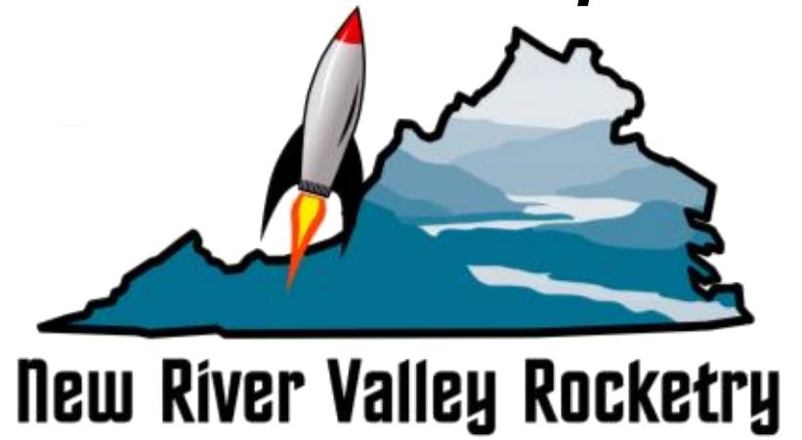
NRV Rocketry Membership Application v2010-02-01a

Your full name: Age:
(to appear on current year NRVR membership card)
For Club Use:

Applying as: (check desired membership, write in $ & total fees)
□ Student ($5) (Include copy of student ID)........................................ $
□ Individual ($20)................................................................................. $
□ Add Family Membership** (add $5)................................................ $
**List other family TRA/NAR #s here:
Additional annual donation ?…………………...................................... $ (opt'l)
Total Annual NRVR Membership & Support Amount..................... $ (total amount)
● ━━━━━━━━━━━━━━━━━━━━━━━━━━━━━━━━━━━━━━━━━━━━━━━━━━━━━━━━━━━━━━━━━━●
If you are member of parent rocketry organization TRA or NAR rocketry organization:
YOUR TRA/NAR #(s): TRA# NAR# (if applicable):
YOUR current Certification Level (1, 2, 3, or 0=n/a ):

If not yet a TRA (Tripoli Rocketry Assn.) or NAR (National Assn of Rocketry) Member:
□ Joining TRA now on your own (requires credit card): TRA registration link http://tinyurl.com/join-tra-2016
□ Joining TRA now through NRV Rocketry? (requires check)
1) Fill out, print & include their form from here: http://tinyurl.com/join-tra-print-2016
2) Include to us a separate check to "Tripoli Rocketry Assn."
NOTE: If joining the TRA now, please send us your new TRA# once you receive your TRA membership card and we will print your NRVR membership card.

Your mailing Address:
Your Phone#: (mobile # preferred)
Your Emergency Contact: name: relation: phone:
Your Email address: @
☑ Will be added to the club email list nrvr-members@nrvr.org for the year.
Check if you would like to:
□ Have your own member forwarding alias?
(for example: first.last@nrvr.org email forwards → your.email@gmail.com )

NRVR MEMBERSHIP LIABILITY & PHOTOGAPHY WAIVER: (New please read & sign)
By submitting this application for New River Valley Rocketry membership, the applicant agrees to:
(1) Adhere to all safety and operations codes associated with the activities undertaken by NRVR and ensure that all children & guests are supervised and adhere to all safety rules and remain within voice range of a responsible adult.
(2) Assumes all risks inherent to rocketry and waive any liability of New River Valley Rocketry, it's members, officers, governing body and launch property owners for their or your activities and/or the activities of others at NRVR events.
(3) Releases photographic rights of the applicant(s) and family members taken at NRVR events, to NRVR and its media partners for use where and how they see fit for all time.
Re-Up Initials
PRINTED NAME:
2020______ 2021_______
SIGN:
2022______ 2023_______
DATE:

----------------------------8<---------SNIP------------------>8---------------
To apply to the NRV Rocketry community club, simply fill in the information
above, print it, include a check or money order to "NRV Rocketry" & mail to:

NRV Rocketry Treasurer
2636 Tulip Ln,
Vinton VA 24179

or email a scanned PDF to treasurer(at)nrvr.org and drop the check in the mail or bring to a NRVR meeting or launch.

If payment by Credit Card is desired, email treasurer(at)nrvr.org for directions and Square payment instructions.

